Homework Assignment 04

Name: Asrar Syed
Due by: December 12, 2025
Course Section: CSC 4222-008

PART A – K-Anonymity (60 points)

Original Microdata Table
Zip Code | Age | Gender | Disease
47677 | 29 | F | Flu
47677 | 27 | F | Cancer
47678 | 43 | M | Flu
47602 | 45 | M | Diabetes
47602 | 47 | M | Cancer
47605 | 31 | F | Flu

Table that achieves 3-Anonymity
Zip Code | Age | Gender | Disease
476** | [27-31] | F | Flu
476** | [27-31] | F | Cancer
476** | [27-31] | F | Flu
476** | [43–47] | M | Diabetes
476** | [43–47] | M | Cancer
476** | [43–47] | M | Flu

To achieve k-Anonymity, according to slides use:
- Generalization: Replace with less-specific values
- Suppression: Remove outliers

We can also replace gender column, F/M option and generalize it to *
PART B – Social Engineering (40 points)

1. Briefly explain how authority bias helps an attacker succeed in a social engineering attack. (20 points)

Authority bias basically makes people trust or obey someone who appears to be in a position of power or expertise. So, if an attacker pretends to be a boss or an IT admin, the victim employee is more likely to do what they ask without thinking too hard about it. They may also feel pressured to obey by the threat of facing consequences for refusing a boss and thus are more likely to reveal information, bypass security procedures, or perform actions they would normally question.

2. Match each social engineering concept below to its correct description. (20 points)

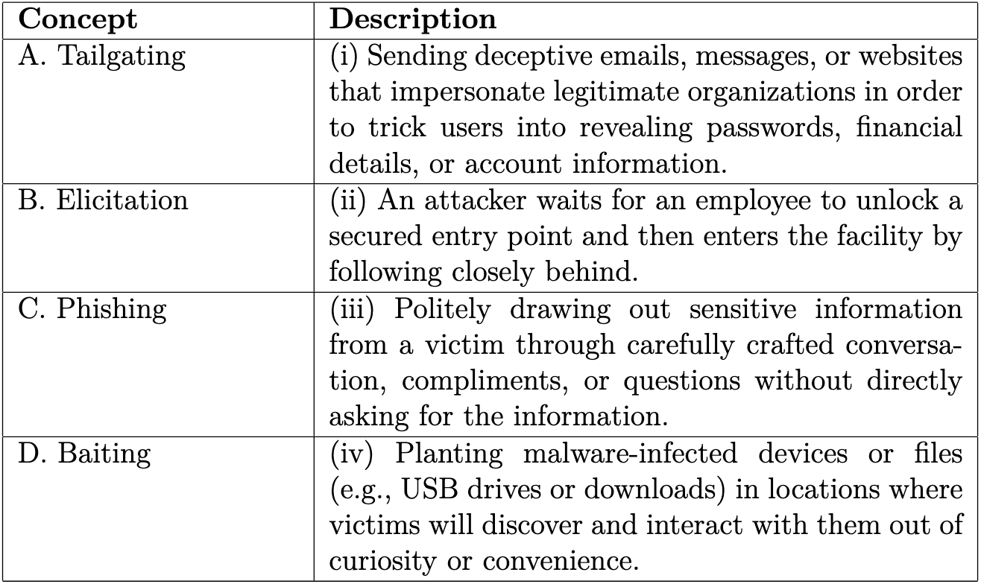

A → ii
B → iii
C → i
D → iv

